Full Name: John Yee Student ID: 12345

Wells international college

**Project Management**

Assessment Two

|  |  |  |  |
| --- | --- | --- | --- |
| Name of Student | Surya Dinata | ID | 18620 |

**Assessment 2 – Research (Online)**

Contents

Instructions: 1

Duration: 2

Multiple-choice Questions: 2

Learning Notes: 7

What is project? 8

Please put your learning notes here: 8

Project management basic 8

Project management History 8

Project management in the future 9

Project Team 10

Document Search Index 10

## Instructions:

This is an individual assessment. Answer all the questions on the document provided by your Trainer.

## Duration:

Trainer will set the duration of the assessment.

## Multiple-choice Questions:

1. 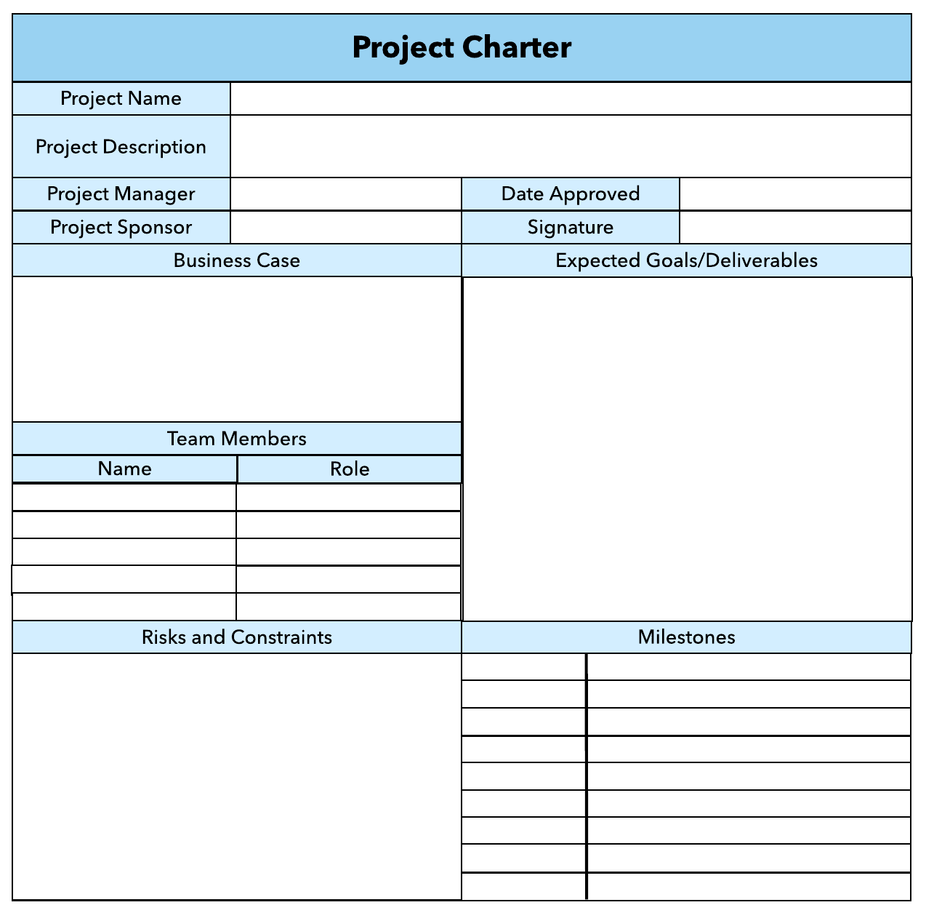What advice do we give about factoring in the commitments of project stakeholders when making your own plans?
   1. Consult student timetables to see when they might be free to attend data collection sessions.
   2. Ask external organizations what the most convenient times would be for you to visit
   3. Neither of these

d) Both A and B

Comment: everyone has different schedule, so it will be better to ask if someone or a group of people is available.

Web ref: <https://sustainet.com/managing-stakeholder-commitments/>

1. Which of the following are essential components of a GANTT chart used to plan your project?
   1. Your home telephone number
   2. Your supervisor’s home telephone number
   3. The email address for the chair of the ethics committee
   4. None of the above

Comment: In ganttchart there are 3 main subject which is time, cost, goal. With each of them very important to be planned.

Web ref: <https://www.proofhub.com/articles/gantt-charts>

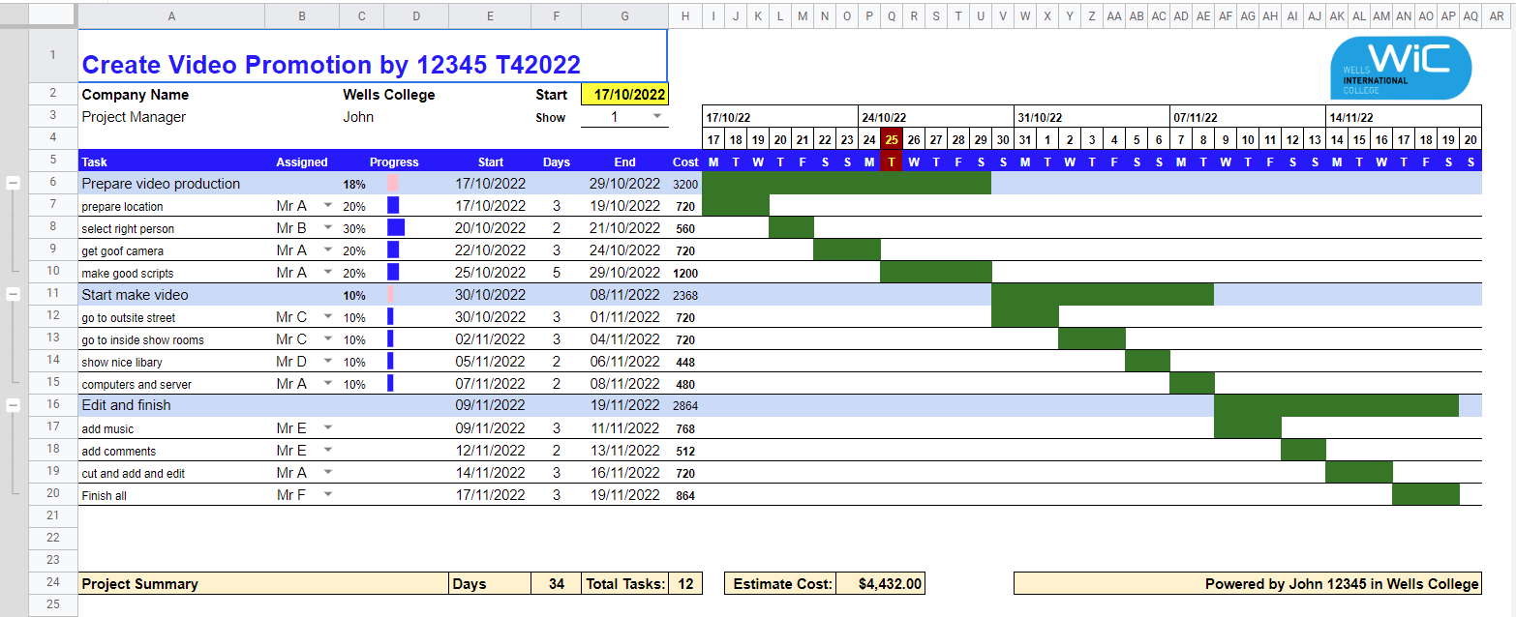

1. The intended outcome of strategy/projects integration is
   1. Clear organization focus
   2. Best use of scarce organization resources
   3. Improved communication across projects and departments
   4. Both A and C are correct
   5. A, B, and C are all correct

Comment : option A is talking about Goal of the project, option B is about what material from company we best use for, option C is about teamwork within company to pursue the best result of the project.



1. Which of the following questions does the organization's mission statement answer?
   1. What are our long-term strategies?
   2. What are our long-term goals and objectives?
   3. How do we operate in the existing environment?
   4. What do we want to become?
   5. All of these are answered by the mission statement

Comment : my answer for this question is B, because for a company to continue operating needs a clear objectives and main goal in the future. The only concern is by what plan can this goal can be reached.

1. Which of the following is not one of the requirements for successful implementation of strategies through projects?
   1. Allocation of resources
   2. Prioritizing of projects
   3. Motivation of project contributors
   4. Adequate planning and control systems
   5. All of these are requirements

Comments : every option is importans so it is true, resource could be used on prioritized project and keep staff member motivated to see the end of the project is also important, and most important is how we planned the whole project.

1. Which of the following is the reason(s) why project managers need to understand their organization's mission and strategy?
   1. To make appropriate decisions and adjustments
   2. To be effective project advocates
   3. To be able to get their job done
   4. Both A and B are correct
   5. A, B, and C are all correct

Comments: A manajer should be able to make a decisive changes in project and to make sure the adjustment wont change the result much, and effectively taking care of the project they working on.

1. Which of these is the highest priority and first strategy required for any organizational change?

a) Communication

* 1. Stress management
  2. Negotiation
  3. Learning
  4. Employee involvement

Comments : communication within organization is very important because not everything goes as planned so any adjustment should be confirmed between departments.

1. Which of the following is not a procedure to obtain an understanding risk in the planning stage (described in ISA 315):
   1. Inquiries of management
   2. Analytical procedures
   3. Observation and inspection
   4. Procedures for sampling audit tests

Comments : sampling audit tests is used to get a result of a batch made items by picking a random one and do a check on it.

1. Assessment of control risk includes three steps. Which of the following is not one of these steps?
   1. Obtaining an understanding of internal controls and documentation of the controls
   2. Evaluate sufficiency and appropriateness of audit evidence
   3. An initial assessment and response to assessed risk based on the design of internal controls resulting in an audit planning memorandum and audit plan
   4. A final assessment based upon test of controls of operating effectiveness

Comments : B option is only affecting quality of a product.

<https://pcaobus.org/oversight/standards/archived-standards/pre-reorganized-auditing-standards-interpretations/details/auditing-standard-no-15_1787#:~:text=Appropriateness%20is%20the%20measure%20of,the%20auditor's%20opinion%20is%20based>.

1. Which of the following are not common internal control documentation techniques used by auditors?

a) Questionnaires

* 1. Company internal control manuals
  2. Narrative descriptions
  3. Check lists

Comments: because every company has their own control manuals which is different from each other so it is not a common steps.

1. Overall response to assessed risk may include:
   1. Identify the absence of key controls (where controls are lacking)
   2. Identify existing controls
   3. Incorporating additional elements of unpredictability in the selection of further audit procedures to be performed
   4. Determine potential material misstatements that could result

Comments: unpredicted and unavoidable things should be included in overall risk as it is could happen in the future.

1. Action plan Should be
   1. Specific
   2. Countable
   3. Realistic
   4. Achievable

Comments: my answer is A,C,D because in a plan every stage has its own specific goal, if its not achieved the the plan cannot continue, also the goal should be realistic so it could be Achievable not just a dream.

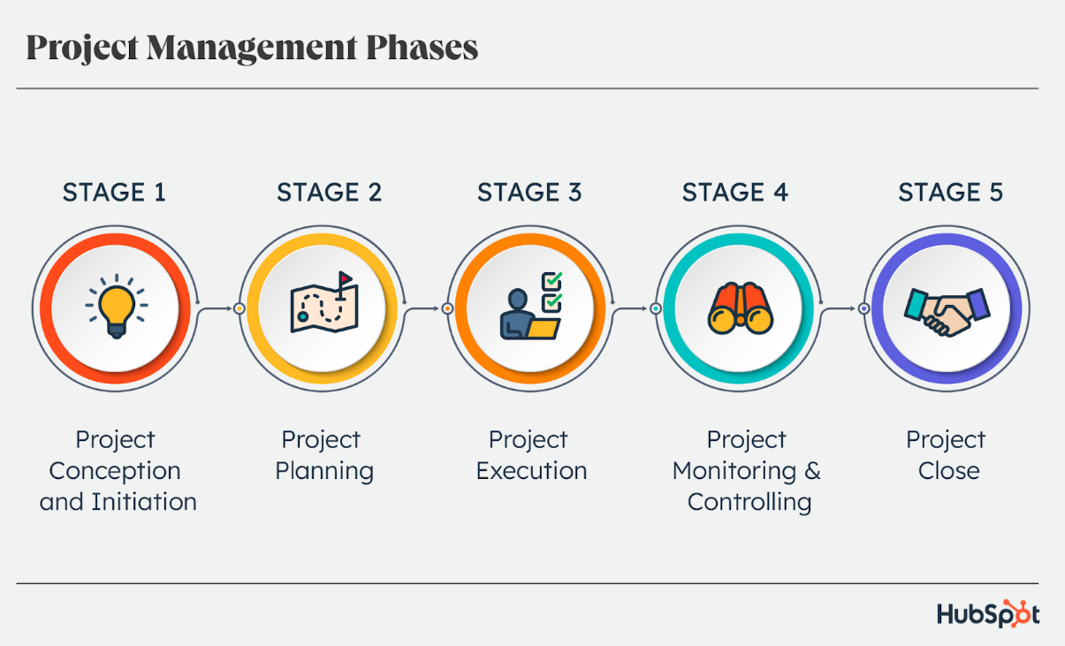

1. Which of the following is not a function of Project Management Tool?
   1. Plan a project
   2. Manage Tasks
   3. Manage Issues
   4. Time Tracking
   5. None of above

Comments: Time tracking is used in Ganttchart but project management tool is used to plan the project to the end.

1. John, the project manager for the ERP Project, is about to complete the project phase review. The completion of a project phase is also known as which of the following?

a) A lesson learned

* 1. A kill point
  2. Earned value management
  3. Conditional advancement

Comments : Lessons learned is a collection of information and knowledge gained through an experience, typically a phase, within the project, so **A** is incorrect. EVM, earned value management, can happen at different times throughout the project, not just at the end of a project phase; therefore, **C** is incorrect. **D,** conditional advancement, is a term used to describe the conditions that must be present for the work to continue on a project. Conditional advancement, however, does not have to happen only at the end of a project phase.

<https://www.cram.com/flashcards/pmp-exam-practice-test-2b-project-life-cycle-and-the-organization-5627884#:~:text=The%20completion%20of%20a%20project%20phase%20may%20also%20be%20known,project%2C%20so%20A%20is%20incorrect>.

1. Which of the following is not a key stakeholder in a project that creates a service internal to an organization?
   1. The project manager
   2. External customers
   3. Project vendors
   4. Project team members

Comments : customer has no influence on the project plan but they have the authority to judge if a project is a successful one or no.

1. Managing a project is best described as which one of the following?
   1. Establishing direction
   2. Functional controls over the project team and stakeholders
   3. Consistently producing key results expected by stakeholders
   4. Motivating and inspiring the project team to produce results that are expected by project stakeholders

Comments : by meeting the expectation of stakeholder it may increase the popularity and investment of the project which also widen the chance of the project to be successful.

1. You are the project manager for your organization. Influencing your organization requires which of the following?
   1. An understanding of the organizational budget
   2. Research and documentation of proven business cases
   3. An understanding of formal and informal organizational structures
   4. Positional power

Comments: Knowing the structures either formal or informal of a organization could also be helpful to manajer as they could also become closer to project member which could boost the result of their project.

1. What is the difference between a standard and a regulation?
   1. Standards are mandatory; regulations are not.
   2. Standards are optional; regulations are not.
   3. Regulations and standards are essentially the same.
   4. Regulations are usually mandatory; standards may be seen as guidelines.

Comments: To me, Standard is an expectation but regulation is the step that must be done.

a regulation is a set of rules outlined by the government that must be followed as a minimum standard. A regulation is enforceable by law, so as workers, following regulations is mandatory. On the other hand, equipment standards are generally established by private sector bodies.

<https://www.scannable.io/blog-posts/standards-and-regulations-what-are-the-differences#:~:text=In%20simple%20terms%2C%20a%20regulation,established%20by%20private%20sector%20bodies>.

1. Which of the following is an example of a deliverable at the end of the requirements-gathering phase in a software design project?
   1. Responsibility matrix creation
   2. Detail design document
   3. Business needs
   4. Project team assembled

Comments : The need of a client company is the main goal to a project, which is why it could be put in the requirement of a project.

1. At what point in a project would a kill point be acceptable?
   1. When a project team member is not performing as planned
   2. When a project reaches the end of a project phase
   3. When a project reaches the end of its budget
   4. When a project manager determines the project team cannot continue

Comments : a kill point can be done if a task doesn’t possess much influence if project time near the end.

1. Of the following, which is not an exit criterion?
   1. Customer sign-offs
   2. Quality metrics
   3. Stakeholder analysis
   4. Regulatory inspections

Comments : Stakeholder may use their power to bring the project close to what they expect but their analysis isn’t important because the project has been planned before so by using another analysis might change the result of a project which is impossible to finish near the end.

1. At which point is the risk of failure the least but the consequence of failure the highest?

a) During the early stages

* 1. During the middle stages
  2. During the final stages
  3. Risk of failure is even across all project phases

Comments: Because every result is being put together at the final stage of a project so if any problem occurred it would have a high rate of failure.

**The final stage, Closing, is the least risky, but the risk of project failure is still present.**

Most failure risk in the Closing stage is tied to earlier unaccounted-for issues that do not present themselves until the very end.

<https://www.mentorworks.ca/blog/business-strategy/project-failure-risk-strategies/#:~:text=The%20final%20stage%2C%20Closing%2C%20is,themselves%20until%20the%20very%20end>.

1. In project estimation, project manager has to provide an expert judgement, which are considered of the following EXCEPT:
   1. Impact of inflation over the project lifecycle
   2. Required labour and labour rates
   3. Material costs and assumptions
   4. Costs of quality
   5. All of above
   6. None of above

Comments: Manager judgement is used only when making a sudden adjustment which is important to shape the result of the project later, which is why decision making is one of the requirement of a manager.

1. Which component is/are included in Quality Management Plan
   1. 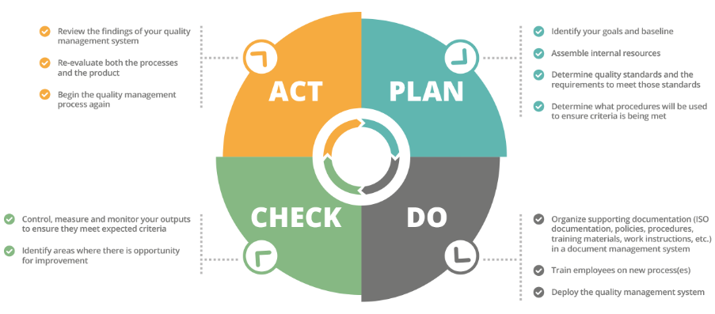Quality objectives
   2. Key project deliverables
   3. Quality standards
   4. Quality control and assurance activities
   5. All of above

Comments: Every quality aspects has to be included in Quality Management Plan.

1. What's an activity sequencing in project management
   1. The process for identifying and documenting dependencies among schedule activities
   2. The process for identifying critical activities
   3. The process for identifying ordering and schedule activities
   4. 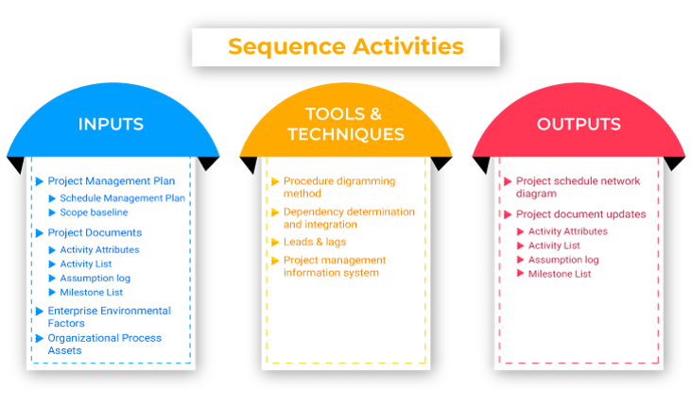The process for planning the project

The strategy of distinguishing and authenticating affiliates amidst the project activities, and sequence activities illustrates the consistent planning of work to get the highest effectiveness of the project constraints. Throughout the project, the process of the execution plan is for better performance.

The sequence activities are designed to fall under [Project Management process groups](https://www.invensislearning.com/blog/project-management-process-groups/) and knowledge areas. By using the results from the procedures, the project schedule development defines sequence activities, estimates activity resources, and estimates activity durations in combination with the scheduling tool to produce the schedule model. The [schedule management plan](https://www.invensislearning.com/blog/plan-schedule-management/) recognizes what scheduling method and device to use for the task, which will manage the activities to be sequenced.

<https://www.invensislearning.com/blog/sequence-activity/>

## Learning Notes:

<https://www.youtube.com/watch?v=rBSCvPYGnTc&t=1323s>

## What is project?

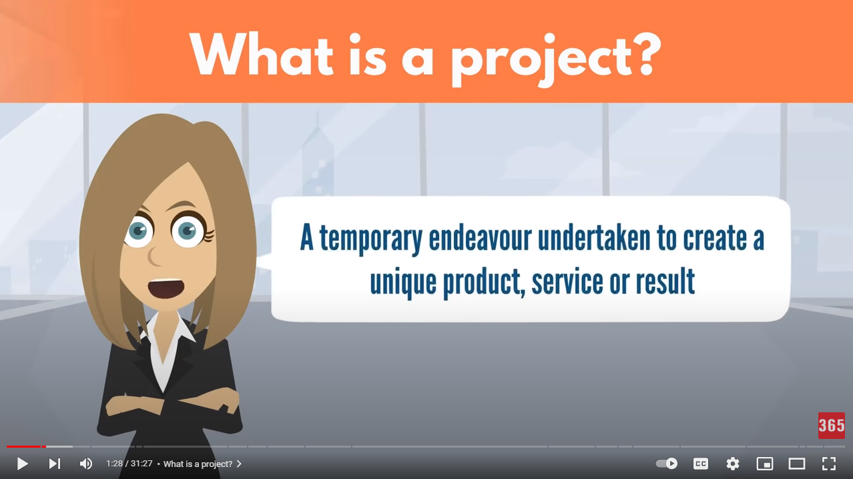

A project is a set of tasks that must be completed within a defined timeline to accomplish a specific set of goals.

Type of projects

1. Types of Projects By Funding Source by looking at their source of capital.

* **Private projects:** Projects that are financed by businesses or private organizations.
* **Public projects:** Projects which are funded by Government agencies.
* **Mixed projects:** Projects that are financed by a public-private partnership.

1. Types of Projects By Industry : Projects can be executed by large or small organizations from any industry. However, some industries are more project-intensive than others. Here are some of the most common types of projects by industry.

* **Construction projects:** The main goal of any [construction project](https://www.projectmanager.com/guides/construction-project-management?) is to make a building that can be used for different purposes such as infrastructure, residential or commercial use.
* **Manufacturing projects:** Manufacturing projects consist of manufacturing physical products to generate profits for a company.
* **IT projects:** Information technology projects consist in establishing an IT framework for the processing of data at a company-wide scale.
* **Software development projects:** The main goal of a software development project is to create a software product for a client.
* **Business projects:** The term business project could refer to creating a new business, creating a new business unit for an existing company or simply launching a new business initiative.

1. Types of Projects By Project Management Methodology : Besides the types of projects mentioned above, projects can also be classified by the project management methodology that’s used to plan, schedule and execute them.

* **Waterfall projects:** [Waterfall](https://www.projectmanager.com/guides/waterfall-methodology?) is the most traditional project management methodology, where the project plan is defined before the project begins and each major project phase must be completed in sequence.
* **Agile projects:** Agile projects are planned and executed in short iterations known as [sprints](https://www.projectmanager.com/guides/agile-sprints?), where project teams plan their activities as they execute the project.

<https://www.projectmanager.com/blog/project-definition>

1. Project management basic

* Project management allows a team to follow and execute a detailed plan within a specific time period.
* [Project managers are responsible](https://www.fool.com/the-ascent/small-business/project-management/articles/project-manager-responsibilities/) for team organization, time management, developing reports and more.
* Your organization could utilize project management software in place of, or in addition to, a project manager.

1. Project management History

Until 1900, civil engineering projects were generally managed by creative architects, engineers, and master builders themselves, for example, Vitruvius (first century BC), Christopher Wren (1632–1723), Thomas Telford (1757–1834), and Isambard Kingdom Brunel (1806–1859). In the 1950s, organizations started to systematically apply project-management tools and techniques to complex engineering projects.

1. Key to notice before starting a project

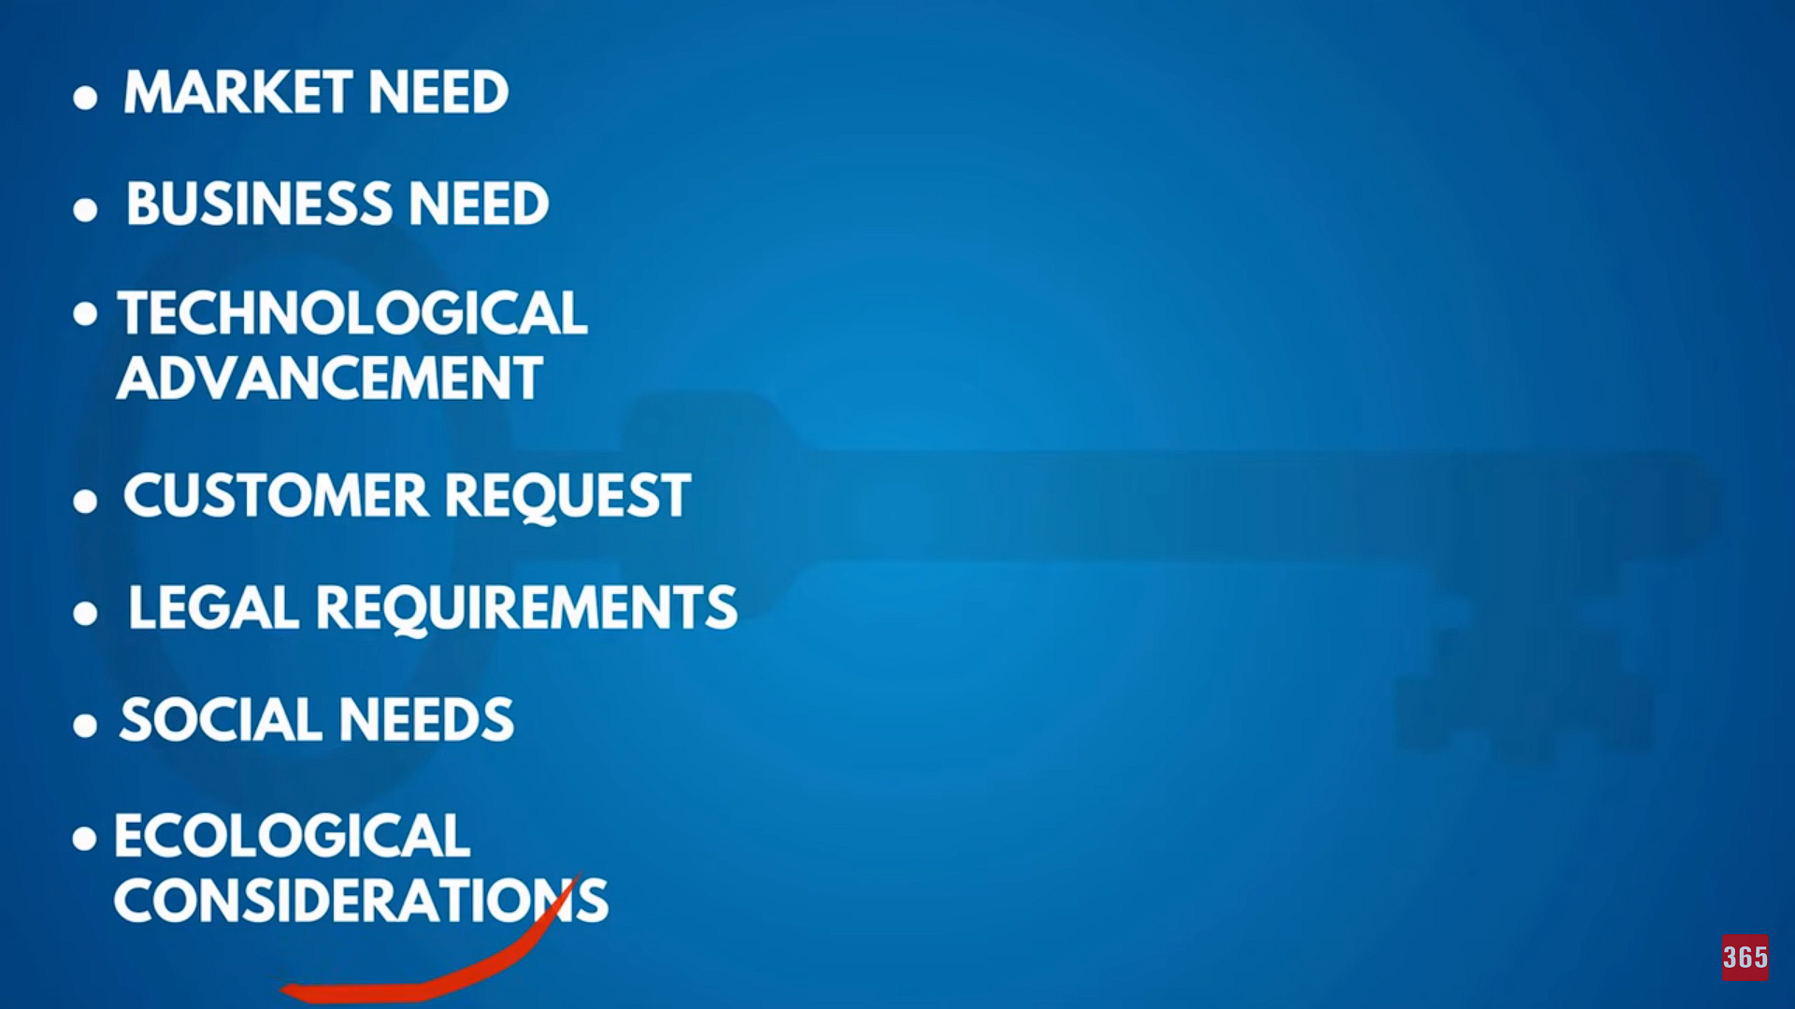

Ancient Egypt Pyramid is an example of a huge project

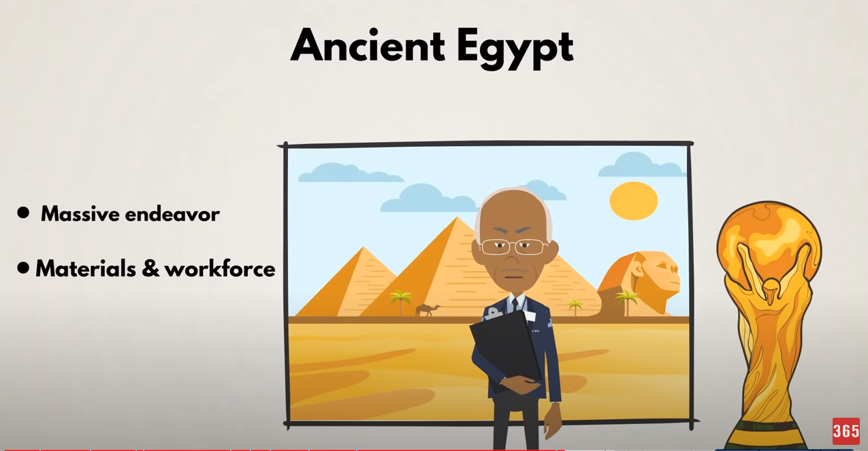

1. GanttChart

Ganttchart is one of the most popular and useful ways of showing activities (tasks or events) displayed against time

The first Gantt chart was devised in the mid 1890s by Karol Adamiecki, a Polish engineer who ran a steelworks in southern Poland and had become interested in management ideas and techniques.

Originally Gantt charts were prepared laboriously by hand; each time a project changed it was necessary to amend or redraw the chart and this limited their usefulness, continual change being a feature of most projects. Nowadays, however, with the advent of computers and project management software, Gantt charts can be created, updated and printed easily.

Today, Gantt charts are most commonly used for tracking project schedules. For this it is useful to be able to show additional information about the various tasks or phases of the project, for example how the tasks relate to each other, how far each task has progressed, what resources are being used for each task and so on.

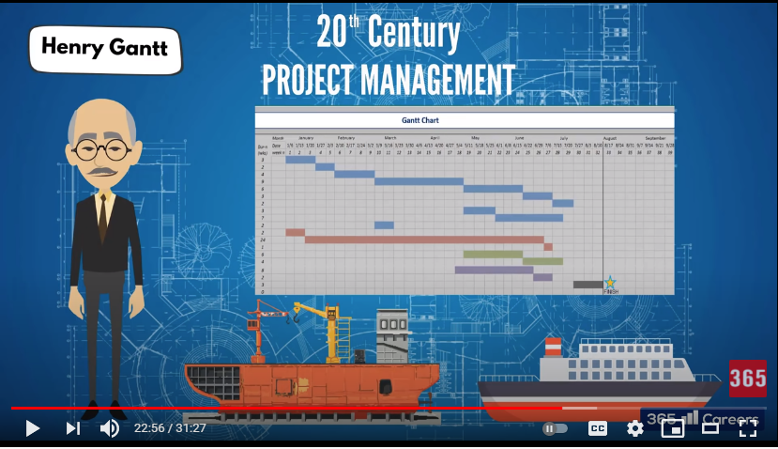

1. Project Manager

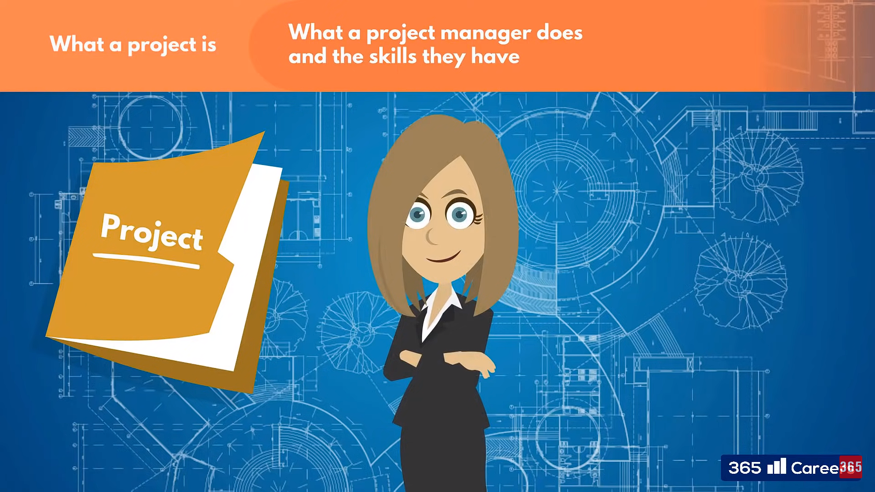

1. Execution

* Drives scope development and management
* Develops and manages project budgets, schedules, and timelines
* Employs strong organizational skills
* Incorporates time management principles into the work flow
* Integrates ongoing risk management trade-offs

2. Decision Making

* Collects and structures the available data impacting the project
* Makes timely decisions based on facts, circumstances, and needs
* Conducts scenario analysis

3. Communications

* Conveys information to all key stakeholders in both written and verbal formats
* Determines and utilizes the appropriate communication channels
* Infers meaningful insights from a collection of data
* Employs active listening
* Prepares and delivers presentations

4. Strategy Development

* Understands the impact of a project directly to and across various functions
* Understands the impact of a project to the overall business
* Integrates business goals into the project scope and deliverables
* Develops metrics to track progress towards goals
* Understands project and organizational dependencies

5. Team Management

* Motivates and inspires the team
* Leads by example
* Manages and resolves conflict
* Builds relationships within and outside the team
* Delegates appropriately
* Demonstrates team organization and governance

6. Business Acumen

* Understands industry trends and their impact on business
* Responds to market and business changes that affect the project and business
* Monitors competition and its impact on the project and business

7. Technical Competence

* Understands and integrates appropriate project management tools and processes
* Applies/obtains the necessary requisite subject matter expertise (SME)

8. Critical Thinking

* Determines the validity of project progress
* Maintains project objectivity
* Applies ongoing analysis to the project
* Integrates the project with cross functional objectives

9. Leadership

* Takes initiative
* Mentors team members
* Effects change and monitors progress
* Responds in a politically astute manner

1. Project Team

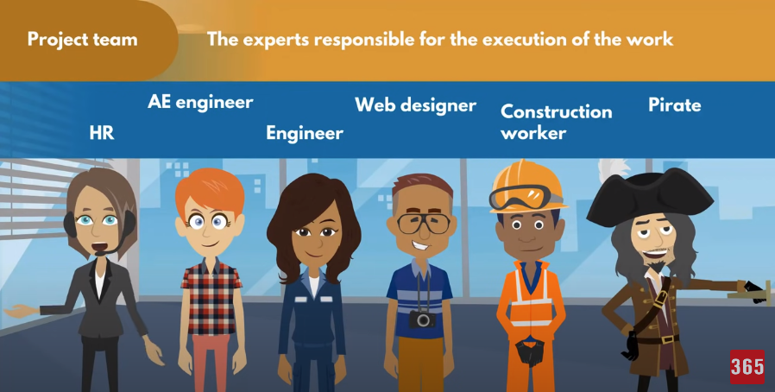

Consisted of many Departmens.